SE 4485: Software Engineering Projects

Fall 2025

Final Report

Group Number | Group 1
Project Title | County Level Air Quality Prediction Application
Sponsoring Company | Raytheon (Team A)
Sponsor(s) | Ryan Havens <Ryan.Havens@rtx.com>,  Marc Perna <marc.perna@rtx.com>,  Trey Williams <trey.williams@rtx.com>,  Trevor Lang <trevor.a.lang@rtx.com>
Students | 1. Jay Chung <cwc130330@utdallas.edu>  2. Amelia Quinn <qcb220000>  3. Kevin Melo <ksm220005>  4. AJ Kimbrough <ank210005>  5. David Santos <des210001>  6. Andrew Enright <ame210008>

ABSTRACT
This document presents the Final Project Report for the County Level Air quality Prediction (CLAP) system, presenting the system’s purpose, requirements, architectural structures, design models, and testing approach. The CLAP system is a web-based predictive analytics application that forecasts the next-day average Air Quality Index (AQI) for U.S. counties using historical data from the U.S. Environmental Protection Agency (EPA). The system processes county-level AQI records, generates lag-based features, and applies a trained machine-learning (ML) model to predict next day AQI values , predicted categories, and model confidence levels through a layered client-server organization with RESTful API backend services.
The Final Project Report summarizes the system’s functional capabilities, quality attributes, and static/behavioral models, along with the system-level tests used to assess conformance to defined requirements. Overall, the CLAP system provides a structured proof-of-concept designed to support environmental awareness.

TABLE OF CONTENTS
- INTRODUCTION 3
- PROJECT MANAGEMENT PLAN 4
- REQUIREMENT SPECIFICATIONS 6
- ARCHITECTURE 12
- DESIGN 27
- TEST PLAN 40
- EVIDENCE OF CONFIGURATION MANAGEMENT
- ENGINEERING STANDARDS AND MULTIPLE CONSTRAINTS
- ADDITIONAL REFERENCES

LIST OF FIGURES
Figure 2.1 – CLAP – Machine-Learning Lifecycle Model 8
Figure 3.1 – CLAP – Graphical Use Case Model 14
Figure 4.1 – CLAP – Client-Server Architecture 19
Figure 4.2 – CLAP – Layered Architecture 19
Figure 4.3 – CLAP – Pipe-and-Filter Architecture 20
Figure 4.4 – CLAP – Package-Level Client-Server Decomposition 21
Figure 5.1 – CLAP – Control Panel Example 29
Figure 5.2 – CLAP – Prediction & Category Probability Panel Example 30
Figure 5.3 – CLAP – Historical Trend Panel Example 31
Figure 5.4 – CLAP – Model Information Panel Example 31
Figure 5.5 – CLAP – Backend Route Subsystems Class Diagram 33
Figure 5.6 – CLAP – Domain / DTO Model Class Diagram 34
Figure 5.7 – CLAP – Forecast Generation Sequence Diagram 35

LIST OF TABLES
Table 1.1 – CLAP – Acronyms, Terms, & Definitions 6
Table 2.1 – CLAP – Risk likelihood, Impact, & Mitigation 8
Table 2.2 – CLAP – Deliverables & Dependencies 9
Table 2.3 – CLAP – Configuration Management – Project Management 11
Table 2.4 – CLAP – Difference Link – Project Management 12
Table 3.1 – CLAP – UC1 Textual Description 15
Table 3.2 – CLAP – UC2 Textual Description 16
Table 3.3 – CLAP – Configuration Management – Requirement Specification 18
Table 3.4 – CLAP – Difference Link – Requirement Specification 18
Table 4.1 – CLAP – Core System Features 20
Table 4.2 – CLAP – Key Architectural Decisions 23
Table 4.3 – CLAP – FR-Architecture Compact Traceability Matrix 24
Table 4.4 – CLAP – NFR-Architecture Compact Traceability Matrix 25
Table 4.5 – CLAP – Configuration Management – Architecture 28
Table 4.6 – CLAP – Difference Link – Architecture 28
Table 5.1 – CLAP – Backend Route Subsystems & Responsibilities 32
Table 5.2 – CLAP – FR-to-Design Traceability Matrix 36
Table 5.3 – CLAP – NFR-to-Design Traceability Matrix 37
Table 5.4 – CLAP – Configuration Management – Design 39
Table 5.5 – CLAP – Difference Link – Design 39
Table 6.1 – CLAP – Test Case #1 40
Table 6.2 – CLAP – Test Case #2 42
Table 6.3 – CLAP – Test Case #3 44
Table 6.4 – CLAP – Test Case #4 45
Table 6.5 – CLAP – Test Case #5 46
Table 6.6 – CLAP – TC-to-UC Traceability Matrix 51
Table 6.6 – CLAP – FR-to-TC Traceability Matrix 51
Table 6.6 – CLAP – NFR-to-TC Traceability Matrix 52
Table 6.6 – CLAP – TC-to-FR/NFR Traceability Matrix 53
Table 6.7 – CLAP – Configuration Management – Test Plan 54
Table 6.8 – CLAP – Difference Link – Test Plan 54

INTRODUCTION
PURPOSE AND SCOPE
This document presents the Final Project Report for the County Level Air quality Prediction (CLAP) system. Its purpose is to present a technical description of the system, including its project management, system objectives, requirement specifications, design models, and testing considerations. The scope of this report includes analytical, architectural, behavioral, and quality-focused elements that define the CLAP system, providing a comprehensive overview.
PRODUCT OVERVIEW
The CLAP system is a web-based predictive analytics application that forecasts the next-day average Air Quality Index (AQI) for U.S. counties using historical AQI measurements published by the U.S. Environmental Protection Agency (EPA). The system automatically ingests EPA datasets, validates and preprocesses the dataset, generates lag-based and temporal features, and applies a trained machine-learning model to produce predictions with probability distributions across EPA-defined AQI categories and labels.
The web dashboard provides intuitive access to next-day predictions, 30-day AQI trends, confidence scores, and category-based visualizations consistent with EPA color standards. Architecturally, the system follows a layered client-server design, where the backend exposes RESTful API endpoints and a frontend renders the visual interactive output. The system prioritizes accessibility and usability, offering rapid data-driven insight.
STRUCTURE OF THE DOCUMENT
The remainder of this document is organized as follows:
- Section 2: Project Management Plan – Describes the project’s organizational structure, lifecycle model, risk analysis, software and hardware resource requirements, deliverables & schedule, monitoring & reporting mechanisms, professional standards.
- Section 3: Requirement Specifications – Describes the system’s functional requirements, non-functional requirements, use case models, and rationale.
- Section 4: System Architecture – Describes the system’s architectural style, model, technology used, rationale, and traceability.
- Section 5: Detailed Design – Describes the system’s graphical user interface (GUI) design, static models (e.g. class diagrams), dynamic models (e.g. sequence diagram), and rationale.
- Section 6:Test Plan – Describes the system’s requirements/specifications-based system-level test cases, techniques used for test generation, assessment of the test suite, and traceability of test cases to use cases.
- Section 7: Evidence of Configuration Management – Describes the document’s version control practices.
- Section 8: Engineering Standards & Multiple Constraints – Lists applicable standards and identifies constraints.

TERMS, ACRONYMS, AND ABBREVIATIONS
Table 1.1 – Acronyms, Terms, & Definitions
Acronym: | Term: | Definition:
AQI | Air Quality Index | A numerical scale developed by the U.S. Environmental Protection Agency (EPA) that represents daily air-quality conditions and associated health implications.
API | Application Programming Interface | A defined set of protocols and data formats that allows software components to communicate with each other through standardized requests and responses.
CSV | Comma-Separated Values | A simple, text-based file format used to store tabular data where each row is a record; used for preprocessing.
EPA | Environmental Protection Agency | A U.S. federal agency responsible for collecting environmental data, enforcing regulations, and publishing public resources such as historical AQI measurements.
GUI | Graphical User Interface | A visual interface that enables user interaction through graphical elements such as buttons and charts.
HTTP | Hypertext Transfer Protocol | A standardized communication protocol used by web clients and servers to exchange requests and responses over the internet.
JSON | JavaScript Object Notation | A lightweight, text-based data format used for structured data exchange between systems.
ML | Machine Learning | A computational approach that enables systems to learn patterns from data and generate predictions or decisions without being explicitly programmed for each task.
REST | Representational State Transfer | A lightweight architectural style for designing web services where resources are accessed using stateless HTTP requests and structured data representations (e.g. JSON)
WCAG | Web Content Accessibility Guidelines | An internationally recognized set of accessibility standards that define how to design digital content usable by individuals with disabilities.
PROJECT MANAGEMENT PLAN
PROJECT ORGANIZATION
The CLAP project is structured into four major phases: data processing pipeline, model development, website development, and system integration & testing. The team consists of six members working collaboratively as a unified group during early development stages to maintain flexibility. Roles include team leadership, software developers, documentation architects, and CI/CD managers. Responsibilities include project management, ML model development, data pipeline development, backend development, frontend development, configuration management, testing & QA. Subgroups may be formed to meet stakeholder expectations.
Team Members and Roles:
- David Santos: Project lead, software & ML engineer; responsible for backend, frontend, system deployment project success.
- Kevin Melo: Software engineer; responsible for system design & model optimization.
- AJ Kimbrough: Software engineer; database admin, lead architect & data pipeline.
- Jay Chung: Team leader, software & ML engineer; responsible for email communications, timely documentation submissions, presentation slides, and model research.
- Amelia Quinn: Software & ML engineer; responsible for testing & QA, documentation quality, and CI/CD & configuration management.
- Andrew Enright: Software engineer; responsible for frontend (UI/UX).

LIFECYCLE MODEL USED
The project follows an iterative lifecycle model, emphasizing repeated refinement of system behaviors expected to meet stakeholder expectations, through sponsor feedback and periodic validation. This approach addresses evolving requirements.
For the ML development, a machine-learning lifecycle consisting of iterative data analysis, data preprocessing, model training, model evaluation & deployment was applied to improve the model’s predictive performance.
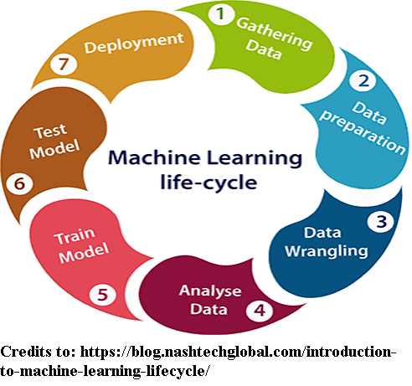
Figure 2.1 – Machine-Learning Lifecycle Model

RISK ANALYSIS
Risk management focuses on factors that negatively influence timely delivery and model performance. The following factors should be considered in order to ensure completion of the CLAP system:

Table 2.1 – Risk Likelihood, Impact, & Mitigation
Risk: | Likelihood: | Impact: | Mitigation: | Rationale:
Implementation Complexity | Less than 50% | More than 50% | TBD | If the project scope expands beyond requirements, then the project will become more complex.
AQI Data Inconsistency | Less than 50% | More than 50% | TBD | If historical AQI data is inconsistent or unreliable, then the model’s predictions will be less accurate.
Lack of Team Coordination | Less than 50% | Less than 50% | Weekly Meetings, weekly reports, communication with hosts, and clear task ownership | If the project team does not maintain communication and task ownership, then development may stall and errors increase.

SOFTWARE AND HARDWARE RESOURCE REQUIREMENTS
Development uses a manageable technical environment intended for ease of testing and deployment. Software resources include:
- Python 3.12 for model & backend development
- Pandas, NumPy, Chart.js, and Scikit-learn API for data handling and analysis
- Flask for running the backend development environment
- HTML5, JavaScript, React, and tailwind CSS for frontend development
- Node.js 22.21.0+ and Vite for running the frontend development environment
- CSV files and serialized model artifacts for data persistence
- GitHub for configuration management

DELIVERABLES AND SCHEDULE
The project’s timeline includes document deliverables and weekly status reports addressed to all stakeholders. Each delivery serves as a checkpoint in the development process, ensuring that progress is made in a structured and timely manner. Weekly status reports ensure accountability and alignment with project expectations.

Table 2.2 – Deliverables & Dependencies
Deliverable: | Due Date: | Allocation of Responsibility | Dependencies: | Estimated Time:
Weekly Report | Every Friday | Team leader | N/A | 0.5 hour
Project Management Plan | 09/12/2025 | Entire Team | N/A | 3 hours
Requirements Documentation | 09/26/2025 | Entire Team | Depends on Project Management Plan | 5 hours
Architecture Documentation | 10/24/2025 | Entire Team | Depends on Requirements Documentation | 2 hours
Detailed Design Documentation | 11/07/2025 | Entire Team | Depends on Requirements & Architecture Documentation | 5 hours
Test Plan | 11/21/2025 | Entire Team | Depends on Requirements, Architecture, and Detailed Design Documentation | 6 hours
Final Project Presentation Slides | 12/02/2025 | Entire Team | Depends on Requirements, Architecture, Detailed Design, and Test Plan Documentation | 2 hours
Final Project Report (and document revisions) | 12/05/2025 | Entire Team | Depends on Requirements, Architecture, Detailed Design, and Test Plan Documentation | 8 hours

MONITORING, REPORTING, AND CONTROLLING MECHANISMS
Project monitoring is achieved through a combination of weekly attendance reports and version control.
- Weekly Attendance Reports document team attendance of weekly sponsor meetings and highlight project-related issues. It is submitted via google forms every week for the duration of the project.
- GitHub serves as the platform for version history, peer reviews, and artifact management.

PROFESSIONAL STANDARDS
High professional standards are expected throughout the project, including academic integrity, timely task completion, respectful team collaboration, active communication, and responsibility for deliverables. Guidelines are followed for managing instances of inappropriate behavior, with escalation procedures defined.
EVIDENCE OF CONFIGURATION MANAGEMENT
GitHub serves as the configuration management platform for this document. Evidence of configuration tracking is provided through version history tables listing commit hashes, dates, and comparison links showing difference across revisions:
Table 2.3 – Configuration Management – Project Management
ID: | Date of Change: | Version Before: | Version After: | Author: | Review -Change Summary: | Reviewers:
1 | 9/10/2025 | v0.1 (3cd1923) | v0.2 (3e9a96a) | Jay Chung (cwc130330) | Made corrections to all sections. | Amelia Quinn (qcb220000)
2 | 9/10/2025 | v0.2 (3e9a96a) | v0.3 (356393c) | Jay Chung (cwc130330) | Made grammatical & syntactic corrections | Amelia Quinn (qcb220000), David Santos (des210001)
3 | 9/11/2025 | v0.3 (356393c) | v0.4 (d3d317a) | Jay Chung (cwc130330) | Made revisions to Tables. Fixed spelling error (page 1). | All team members
4 | 9/16/2025 | v0.4 (d3d317a) | v0.5 (e92db76) | Jay Chung (cwc130330) | Updated problem statement. Made revisions to all sections. | All team members
4 | 9/16/2025 | v0.5 (e92db76) | v0.6 () | Jay Chung (cwc130330) | Made revisions to all sections. | All team members

Table 2.4 – Difference Link – Project Management
ID: | Difference Link:
1 | https://github.com/cchung7/rtx_team1/compare/3cd1923..3e9a96a
2 | https://github.com/cchung7/rtx_team1/compare/3e9a96a..356393c
3 | https://github.com/cchung7/rtx_team1/compare/356393c..d3d317a
4 | https://github.com/cchung7/rtx_team1/compare/d3d317a..e92db76
5 | https://github.com/cchung7/rtx_team1/compare/e92db76..

IMPACT OF THE PROJECT ON INDIVIDUALS AND ORGANIZATIONS
CLAP integrates environmental awareness, social accessibility, and economic efficiency by using public datasets, open-source technologies, and inclusive design principles to provide low-cost, high-impact air quality insights.
The project considers the following factors:
- Global & environmental: CLAP helps people understand and respond to environmental conditions, supporting sustainability awareness and informed personal & societal decisions on a global scale.
- Social & cultural: CLAP supports diverse user groups by being easy to access, easy to understand, and aligned with widely recognized public-health communication standards.
- Economic: CLAP is inexpensive to run and maintain, making it accessible to organizations with limited budgets and encouraging wider adoption for educational or public-health services.

REQUIREMENT SPECIFICATIONS
STAKEHOLDERS FOR THE SYSTEM
Stakeholders represent individuals or entities that interact with or are impacted by the CLAP system. Primary stakeholder groups include:
- Development Team: The group of student engineers responsible for specifying, modeling, designing, and demonstrating the system. They collectively contribute to documentation, risk management, software implementation, and quality assurance throughout the project lifecycle.
- End Users: Individuals seeking next-day average county-level air quality insight, including students, researchers, and individual users.
- Maintainer: A user responsible for supplying the system with the most recent EPA AQI dataset and making updates to the ML model. This stakeholder ensures that forecasting workflows have current data for generating accurate predictions.
- Sponsoring Organization: Project sponsors who provide expectations, review deliverables, and evaluate technical correctness & feasibility of the system.
- Course Instructors: Project regulators & process supervisors who review weekly attendance reports, evaluate deliverables, ensure adherence to software-engineering standards & templates, and provide academic oversight.
- EPA: Serves as the provider of the historical county-level AQI dataset used for feature generation & model prediction. The EPA’s dataset is essential for CLAP’s functionality.

USE CASE MODEL FOR FUNTIONAL REQUIREMENTS
The functional requirements define the system’s core capabilities across data ingestion, data processing, predictive analytics, and dashboard visualization. The use case model is structured around two primary system behaviors: Ingest Daily AQI and Provide county-level forecast.
Functional Requirements:
- Data Ingestion:
- FR-1.1: The system shall utilize daily AQI data from the Environmental Protection Agency (EPA), ingested manually from provided datasets.
- Data Processing:
- FR-2.1: The system shall store historical AQI data in a structured local dataset.
- FR-2.2: The system shall generate lag features for use in prediction.
- Predictive Analytics:
- FR-3.1: The system shall load a trained model and run predictions using historical AQI data and county location.
- FR-3.2: The system shall output a next-day AQI category for a selected county.
- FR-3.3: The system shall provide the prediction with an associated probability score for each AQI category.
- Dashboard:
- FR-4.1: The system shall provide a graphical user interface (GUI) for visualizing AQI data and predictions.
- FR-4.2: The system shall display a 30-day historical AQI trend and the next-day predicted category with associated probabilities for the selected country.
- FR-4.3: The system shall provide a Refresh control that updates the dashboard using locally stored dataset and regenerates the forecast.

Use Case Model Decomposition:
- UC1 – Ingest Daily AQI: Supports the maintainer’s task of updating the local dataset by providing new EPA AQI data and enabling the system to process, validate, and store analytical features for prediction.
- UC2 – Provide County-Level Forecast: Supports the end user’s ability to request and view a next-day AQI forecast, along with recent historical trends & category probabilities.

GRAPHICAL USE CASE MODEL
The graphical use case model includes two primary actors: maintainer (UC1) and end user (UC2), illustrating a clean separation of operational flows.
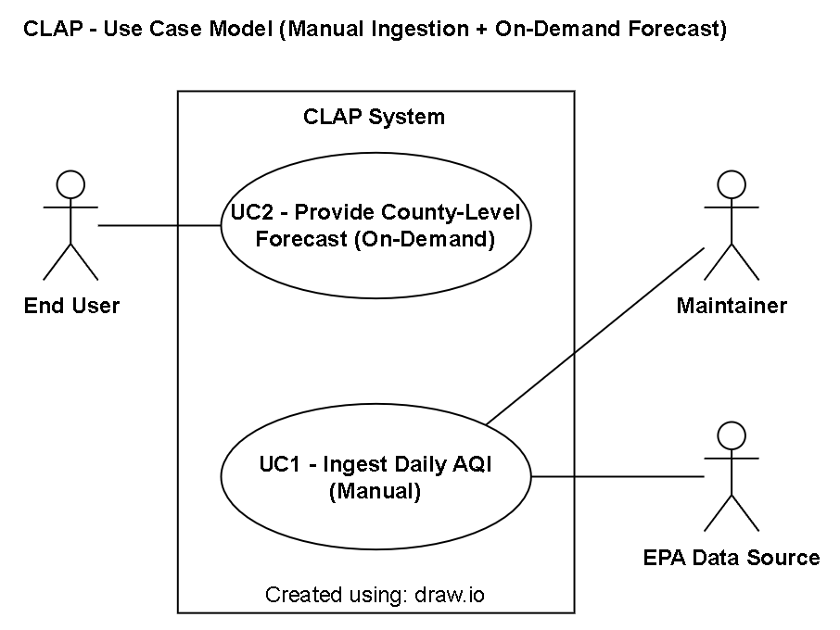
Figure 3.1 – Graphical Use Case Model

TEXTUAL DESCRIPTION FOR EACH USE CASE
Table 3.1 – UC1 Textual Description
Title: | Ingest Daily AQI
Primary Actor: | Maintainer | Goal: | Provide the system with the latest EPA AQI file and allow the system to preprocess it.
Supporting Actors: | EPA Data Source | Traceability to FRs: | FR-1.1, FR-2.1, FR-2.2
Entry Conditions: | - The CLAP application is available to run.  - Network access is available to download the EPA AQI file.  - There is sufficient local storage to save processed data and lag features.
Normal Flow of Events: | - Maintainer manually downloads the EPA daily AQI file.  - Maintainer places the file into the system’s designated input location.  - Maintainer executes the processing workflow, which allows the system to load the file.  - System validates the file structure and values.  - System cleans and normalizes AQI records.  - System generates lag features.  - System saves the processed dataset locally.  - System produces ingestion logs.
Success Condition: | - A processed, feature engineered, and ML-ready EPA AQI file is generated & persisted for use in local storage.  - Ingestion metadata (e.g. timestamp, status, etc.) has been logged.  - The system is ready to use the updated dataset for future forecasts.
Exceptions: | - EPA data unavailable (download failure):  - No new ingest is performed.  - The system logs an error indicating that the new file could not be obtained.  - Invalid or incompatible file format:  - The system rejects the file and does not generate a new dataset.  - The system logs an error describing the failure.  - Data validation, processing, or feature generation failure:  - The ingest process is stopped or rolled back.  - The system logs error details describing the failure.

Table 3.2 – UC2 Textual Description
Title: | Provide County-Level Forecast
Primary Actor: | End User | Goal: | Present the next-day AQI prediction and historical trend for the selected county.
Supporting Actors: | N/A | Traceability to FRs: | FR-3.1, FR-3.2, FR-4.1, FR-4.2, FR-4.3
Entry Conditions: | - The CLAP application is running.  - Network access is available.  - The dashboard is accessible to the end user through a web browser.  - A processed dataset is available in local storage.  - A pre-trained predictive model artifact is available and loadable by the backend.
Normal Flow of Events: | - User selects state and county.  - User clicks “Generate Forecast”.  - System retrieves the locally stored processed dataset.  - System loads the pre-trained ML model.  - System runs inference to predict next-day AQI.  - System maps AQI value to the correct EPA category label.  - System generates category probability scores.  - System responds to the dashboard with the prediction and historical data.  - Dashboard updates the trend graph and prediction display.
Success Condition: | - The system loads and executes the pre-trained model to produce a next-day AQI prediction.  - The dashboard displays prediction scores and category probabilities for each EPA AQI category.  - The dashboard displays a 30-day historical AQI chart for the selected county.
Exceptions: | - No processed dataset available:  - The dashboard displays a warning banner notifying the user that no data is available for forecasting.  - The system logs an error indicating that data is unavailable.  - Model file is missing or corrupted:  - The dashboard displays a warning banner notifying the user that the prediction model is unavailable.  - The system logs an error indicating that data is unavailable.

RATIONALE FOR YOUR USE CASE MODEL
The use case model separates data maintenance activities (UC1) from end-user forecasting activities (UC2) to improve performance, testability, and simplify system behavior. This decomposition follows a black box testing perspective, allowing for cleaner traceability between use cases, functional requirements, and future test cases.

NON-FUNCTIONAL REQUIREMENTS
The non-functional requirements (NFRs) define the system’s quality attributes and operational constraints of the system. Each requirement category is ranked numerically to indicate its relative importance for meeting stakeholder expectations:
- Performance:
- NFR-1.1: The system shall complete ingestion, validation, and feature generation for one county in ≤ 60 seconds.
- NFR-1.2: The system shall render the dashboard in ≤ 5 seconds (p95) after end user clicks Refresh.
- Usability:
- NFR-2.1: The dashboard shall present AQI categories using standard EPA labels (e.g. Good, Moderate, Unhealthy for Sensitive Groups, Unhealthy, Very Unhealthy, Hazardous).
- NFR-2.2: The dashboard shall present each EPA category with a unique, distinguishable color code consistent with EPA/AirNow guidance (e.g. green, yellow, orange, red, purple, maroon).
- Accessibility:
- NFR-3.1: The system shall conform to WCAG 2.1 Level AA accessibility requirements for visual content (e.g. SC 1.4.1 “Use of Color”, SC 1.4.3 “Contract (Minimum)”, SC 1.4.11 “Non-text Contrast”).
- Reliability:
- NFR-4.1: Daily ingest shall succeed on ≥ 90% of runs.
- Availability:
- NFR-5.1: The CLAP dashboard shall be available for use by end users at least 99% of the time over any rolling 30-day period once deployed.
- Maintainability:
- NFR-6.1: The system shall implement structured logging for key operations (ingestion, validation, feature generation, and prediction).
- NFR-6.2: Log entries shall include timestamps and error details.

EVIDENCE OF CONFIGURATION MANAGEMENT
GitHub serves as the configuration management platform for the requirement specification. Evidence of configuration tracking is provided through version history tables listing commit hashes, dates, and comparison links showing difference across revisions:
Table 3.3 – Configuration Management – Requirement Specification
ID: | Date of Change: | Version Before: | Version After: | Author: | Review -Change Summary: | Reviewers:
1 | 9/10/25 | v0.1 (bb4d945) | v0.2 (bfc15f4) | AJ Kimbrough (ank210005) | Added refresh workflow pipeline. Updated NFRs and use case. | Jay Chung (cwc130330), Amelia Quinn (qcb220000)
2 | 9/22/25 | v0.2 (bcf15f4) | v0.3 (f542477) | Jay Chung (cwc130330) | Revised all sections. | All Team Members
3 | TBD | v0.3 (f542477) | v0.4 (3f36a14) | Jay Chung (cwc130330) | Revised Use case and Requirements. | All Team Members
4 | TBD | v0.4 (3f36a14) | v0.5 () | Jay Chung (cwc130330) | Added Traceability (UC & FR), Revised NFRs. | All Team Members

Table 3.4 – Difference Link – Requirement Specification
ID: | Difference Link:
1 | https://github.com/cchung7/rtx_team1/compare/bb4d945..bfc15f4
2 | https://github.com/cchung7/rtx_team1/compare/bfc15f4..f542477
3 | https://github.com/cchung7/rtx_team1/compare/f542477..3f36a14
4 | https://github.com/cchung7/rtx_team1/compare/3f36a14..

ARCHITECTURE
ARCHITECTURAL STYLE(S) USED
The CLAP system adopts a combination of architectural styles that support modularity, maintainability, and testability.
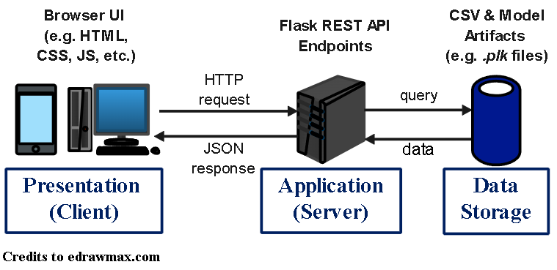
Figure 4.1 – Client-Server Architecture
The primary style is a client-server architecture, where a browser-based frontend (e.g. presentation layer) communicates with a backend (e.g. application layer) prediction service through RESTful HTTP requests. This separation ensures that user interaction, model execution, and data management pipelines are isolated in distinct subsystems that can evolve independently.
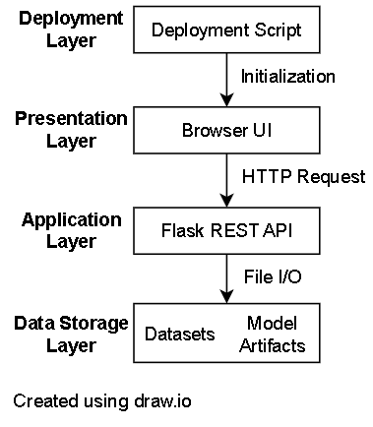
Figure 4.2 – Layered Architecture

A layered architecture organizes the system into the Presentation layer, Application layer, and Data layer:
- Presentation layer: Frontend subsystem that handles user interaction and forecast visualization.
- Application layer: Manages request handling, model inference, and business logic.
- Data layer: Generates and maintains processed AQI datasets, lag features, and serialized model artifacts.
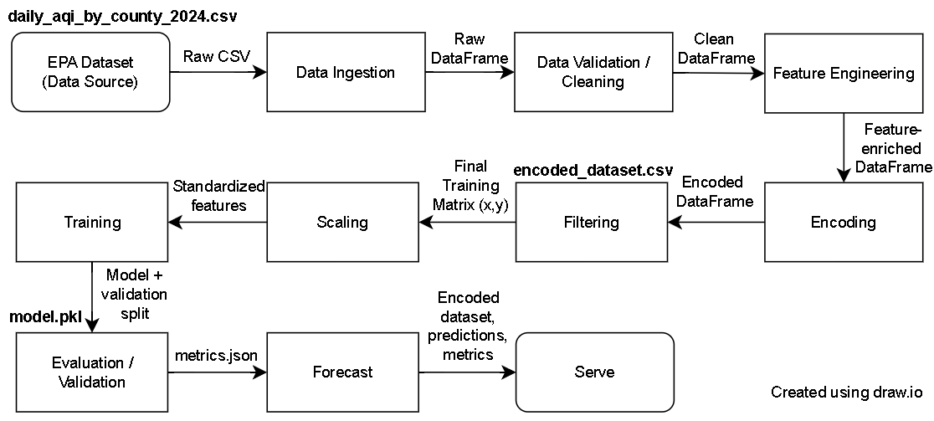
Figure 4.3 – Pipe-and-Filter Architecture
During data ingestion and preprocessing, the system adopts a pipe-and-filter architectural pattern. In this pattern, data flows sequentially through discrete transformation stages. This approach supports predictable data transformations and simplifies verification of dataset integrity.
Table 4.1 – Core System Features
System Features: | Architectural Support Description:
Manual Data Ingestion: | The Application Layer handles on-demand ingestion, connecting to EPA endpoints and validating schema before persistence.
Data Persistence: | The Data Layer manages cleaned AQI data, lag features, and model outputs using CSV and model artifacts.
Model Training & Prediction: | The Application Layer orchestrates model training & inference, ensuring modular separation between data, logic, and presentation.
Interactive Dashboard: | The Presentation Layer visualizes AQI trends and predictions, consuming RESTful JSON data served by the backend.
Scalability & Maintainability: | Each subsystem can be modified or upgraded independently (e.g. model re-training, dashboard upgrade, etc.) without disrupting other layers.
Together, these architectural styles enable clarity and modularity, ensuring that system components remain traceable to functional and non-functional requirements.

ARCHITECTURAL MODEL
The layered client-server model is represented using package-style decomposition, where each component represents a functional unit responsible for a distinct concern in the overall design.
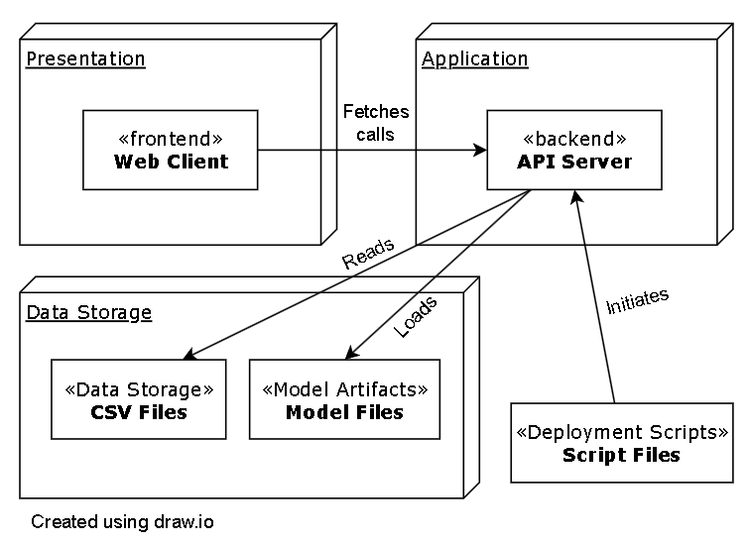
Figure 4.4 – Package-Level Client-Server Decomposition
The layered client-server model is organized into modular subsystems:
- Presentation Layer:
  - Web Client (Frontend): Provides a browser-based dashboard for selecting counties and visualizing predictions. Responsible for retrieving data & predictions via RESTful API calls, and rendering API outputs for the UC2 workflow.
- Application Layer:
  - Flask API Server (Backend): Exposes REST endpoints for historical data retrieval, model inference, and county listings. Responsible for processing datasets to prepare inputs for inference, loading stored model artifacts, and performing forecast predictions.
- Data Storage Layer:
  - CSV Files (Data Storage): Maintains historical AQI datasets, lag features, and preprocessed outputs stored as CSV files.
  - Model Files (Model Artifacts): Stores serialized portable model data.
- Deployment Script: Automated environment setup, backend & frontend startup. Responsible for executing the CLAP program.

COMMUNICATION BETWEEN BACKEND/FRONTEND CLIENT-SERVER LAYERS
The backend communicates with the data layer through local file I/O, while the frontend communicates with the backed through JSON-formatted REST responses, enabling modular evolution across all layers.

TECHNOLOGY, SOFTWARE, AND HARDWARE USED
The CLAP system utilizes lightweight, portable technologies that support rapid deployment and predictable performance.
Technologies & Tools:
- Frontend: HTML5, CSS, JavaScript, React, Node.js, Chart.js, Vite
- Backend: Python 3.13+, Flask
- Machine-Learning: LightGBM, Pandas, Scikit-learn API, NumPy
- Persistence: CSV files and serialized model artifacts (.pkl)
- Version Control: GitHub
Hardware Requirements:
- Dual-core CPU or better
- 8 GB RAM minimum
- ≥ 100 GB available storage
- Internet access

RATIONALE FOR ARCHITECTURAL STYLE & MODEL
The architectural styles and models were selected to support modularity, maintainability, simplicity, portability, and traceability.
- Modularity: The layered client-server model ensures a clean separation between user interface, application logic, and data management.
- Simplicity & Feasibility: Lightweight frameworks and models provide structured templates for complex data science and software engineering principles within the time and resource constraints.
- Scalability & Portability: The architecture remains extensible to cloud environments, ensuring future scalability for handling larger datasets or multi-county inference without major refactoring efforts.
- Traceability & Maintainability: Each subsystem directly supports specific functional or non-functional requirements, enabling clear traceability mappings and supporting ISO-compliant quality assurance evaluations.
This architecture enables CLAP to provide real-time predictions, structured data management, and an accessible interface by balancing complexity, flexibility, and performance.
Key Architectural Decisions:
Table 4.2 – Key Architectural Decisions
Architectural Decision ID: | Topic: | Options: | Decision: | Rationale: | Reqs:
AD-1 | Backend Framework | Flask vs. Django | Flask | Easy local deployment; sufficient for REST. | FR-1.1, FR-2.*, NFR-1.*, NFR-5.1
AD-2 | Data Persistence | CSV vs. MySQL | CSV | CSV for maximizing portability; simplest option. MySQL remains an upgrade path. | FR-2.*, NFR-1.1, NFR-5.1
AD-3 | ML Model | LightGBM vs. XGBoost vs. ARIMA | LightGBM | Time-series regression over Classification to predict numerical AQI over discrete category. LightGBM over XGBoost for faster training & inference; strong tabular performance. ARIMA less suited for categorical output. | FR-3.*, NFR-1.1
AD-4 | API Style | REST vs. GraphQL | REST | Simple, cacheable endpoints. | FR-3.*, FR-4.*, NFR-1.2
AD-5 | Frontend charts | Chart.js | Chart.js | Meets accessibility needs with labels and color mapping. | FR-4.*, NFR-2.*, NFR-3.1
AD-6 | Logging format | Structured JSON vs. plain text | JSON | For meeting logging requirements (e.g. timestamps and error details). | NFR-6.*
AD-7 | Deployment Target | Local laptop vs. Cloud | Local laptop | Satisfies portability constraints. Cloud remains an upgrade path. | NFR-1.2, NFR-5.1

TRACEABILITY FROM REQUIREMENTS TO ARCHITECTURE
Requirements are mapped to architectural elements, showing where and how each requirement is realized in the architectural design.
Table 4.3 - FR-Architecture Compact Traceability Matrix
FR ID: | FR Description: | Architectural Elements: | Interfaces / Artifacts: | How the FR is captured:
FR-1.1 | Utilize daily EPA AQI data, ingested manually. | Deployment Scripts, Backend (API Server), Data Store. | Ingestion endpoint, I/O, Run scripts. | Maintainer triggers manual ingest. API validates and writes cleaned data to CSV.
FR-2.1 | Store historical AQI data in CSV. | Backend, Data Store. | CSV, I/O. | Data Store persists historical datasets. API performs I/O via pandas.
FR-2.2 | Generate lag features for prediction. | Backend, Data Store. | Feature tables, CSV. | API computes lag features and persists outputs alongside base data for reproducible training.
FR-3.1 | Train and run a predictive model using historical AQI + county location. | Backend, Data Store, Model Artifacts. | Training pipeline, LightGBM, .pkl | API loads and saves model artifacts, uses Data Store inputs to train and inter models.
FR-3.2 | Output next-day AQI category for selected county. | Backend, Model Artifacts. | /aqi/predict JSON | API performs inference with loaded model and returns predicted category.
FR-3.3 | Provide probability score for each category. | Backend, Model Artifacts. | /aqi/predict JSON | API includes class probabilities in JSON response.
FR-4.1 | Provide a GUI for visualizing AQI data & predictions. | Frontend | HTML/CSS/JS, Chart.js | Frontend renders history and prediction views, calling API endpoints.
FR-4.2 | Display chart of last 30 days + next-day category with probabilities. | Backend, Frontend | /aqi/historical, /aqi/predict JSON, Chart.js | Frontend queries API, renders 30-day chart and probability display.
FR-4.3 | Provide Refresh control buttons to update from local dataset and regenerates forecast. | Backend, Frontend, Data Store, Model Artifacts. | Refresh control button API calls Data access | Clicking “Generate Forecast” triggers API read of local data, re-runs inference, updates UI.

Table 4.4 - NFR-Architecture Compact Traceability Matrix
NFR ID: | NFR Description: | Architectural Elements: | Interfaces / Artifacts | How the NFR is captured:
NFR-1.1 | Ingestion + validation + features ≤ 60 s for one county. | Deployment Scripts, Backend, Data Store. | Efficient I/O, vectorized feature engineering. | Minimal I/O hops. Scripting ensures optimized local env.
NFR-1.2 | Dashboard renders ≤ 5s after Refresh. | Backend, Frontend. | Small static bundle, compact JSON caching. | Lightweight assets and efficient API response achieves latency target.
NFR-2.1 | Use EPA category labels (e.g. Good…Hazardous). | Frontend | Category mapping, UI labels. | UI uses standard EPA labels in legends.
NFR-2.2 | Use distinct EPA colors per category. | Frontend | Color palette. | Chart.js theme applies target colors (e.g. green, yellow, orange, red, purple, maroon).
NFR-3.1 | Conform to WCAG 2.1 AA (SC 1.4.1, 1.4.3, 1.4.11). | Frontend | Contrast checks, non-color cues, Accessible Rich Internet Applications (ARIA). | UI provides sufficient contrast, non-color indicators, and accessible semantics.
NFR-4.1 | Daily ingest succeeds on ≥ 90% of runs. | Deployment Scripts, Backend, Data Store. | Retries & backoff. Atomic writes & health checks. | Retry policies and atomic persistence improve success rate.
NFR-5.1 | Dashboard availability ≥ 99% over any 30-day period. | Deployment Scripts, Backend, Frontend. | Stateless API. Simple deploy. | Static frontend and simple Flask service minimize downtime. Scripts standardize recovery.
NFR-6.1 | Implement structured logging for key operations. | Backend, Deployment Scripts. | Structure logs (JSON / text) | Logs emitted for ingest, validation, feature engineering, and prediction.
NFR-6.2 | Logs include timestamps and error details. | Backend. | Logger configuration. | Logger attaches ISO timestamps and error metadata to entries.

EVIDENCE OF CONFIGURATION MANAGEMENT
GitHub serves as the configuration management platform for the architecture document. Evidence of configuration tracking is provided through version history tables listing commit hashes, dates, and comparison links showing difference across revisions:
Table 4.5 – Configuration Management – Architecture
ID: | Date of Change: | Version Before: | Version After: | Author: | Review -Change Summary: | Reviewers:
1 | 10/12/25 | v0.1 (26b1e4b) | v0.2 (5c314e8) | Jay Chung (cwc130330) | Peer Review - Consistency pass for all Sections | All Team Members
2 | 10/14/25 | v0.2 (5c314e8) | v0.3 (e8880e3) | Jay Chung (cwc130330) | Traceability & Consistency pass | All Team Members
3 | 10/17/25 | v0.3 (e8880e3) | v0.4 () | Amelia Quinn (qcb220000) | Fixed: Engineering Standards & Titles.  Added: Key Arch. Decisions | All Team Members

Table 4.6 – Difference Link – Architecture
ID: | Difference Link:
1 | https://github.com/cchung7/rtx_team1/compare/26b1e4b..5c314e8
2 | https://github.com/cchung7/rtx_team1/compare/5c314e8..e8880e3
3 | https://github.com/cchung7/rtx_team1/compare/e8880e3..

DESIGN
GUI (GRAPHICAL USER INTERFACE)
The Graphical User Interface (GUI) provides an interactive environment for users to view, interpret, and explore county-level AQI forecasts. It is designed as a modular and responsive dashboard composed of independent yet integrated display panels that collectively support intuitive data interpretation during user interactions.
Key Design Objectives:
- Clarity & Accessibility: Use of descriptive labels, readable typography, accessible color contrast, and keyboard navigation consistent with WCAG 2.1 AA guidelines.
- Consistency: A unified layout and color palette mapped to EPA AQI categories to simplify visual interpretation.
- Responsiveness: Layout that adapts to various screen sizes and devices without sacrificing readability.
- Feedback: Visual indicators for loading, errors, and model status to keep users informed about system behavior.
GUI Design Intent:
This design emphasizes user experience at the architectural level while abstracting away from specific implementation details or technologies. The interface is organized using a modular subsystem layout, allowing new visualization panels or user-integration elements to be integrated without altering the core framework. Each panel conforms to a consistent API contract and visualization standard, ensuring long-term scalability and design consistency.
The GUI communicates with backend services through RESTful API endpoints. Each user interaction (e.g. clicking “Generate Forecast”) triggers asynchronous data retrieval and visualization updates, ensuring real-time responsiveness without requiring a full page reload.
Major Interface Panels:
- Header Panel: The header panel displays the application’s title and branding elements of choice.
- Control Panel: The control panel provides user interaction mechanisms that allow selection of input parameters and initiation of forecast generation. Its primary purpose is to facilitate configuration and execution of forecast requests by collecting necessary user inputs.
  - Responsibilities:
    - Present available parameters (e.g. model type, county, etc.) in an accessible, structured form.
    - Initiate backend communication for data retrieval, feature generation, and prediction upon user confirmation.
    - Ensure accessibility compliance (e.g. WCAG 2.1 AA) for all interactive controls and maintain clear feedback for user actions (e.g. loading, etc.).
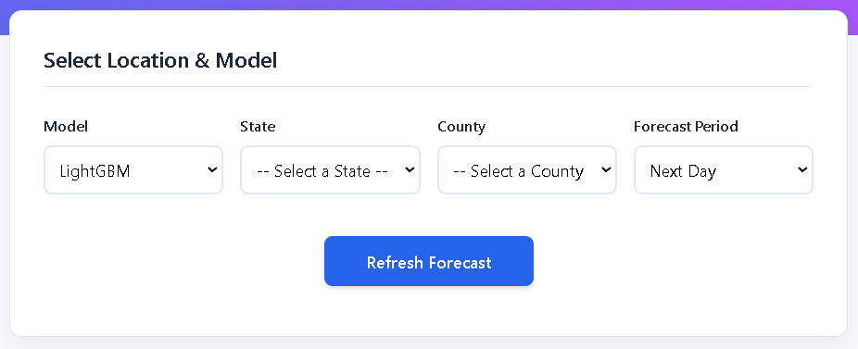
Figure 5.1 – Control Panel Example

- Prediction Panel: The prediction panel communicates the system’s next-day average AQI forecast for the selected county. Its primary purpose is to present results from the predictive ML model in a concise, interpretable format.
  - Responsibilities:
    - Display the predicted AQI category and corresponding index value generated by the model.
    - Provide contextual cues (e.g. “Avg AQI Forecast for <dateTime>”) to maintain situational awareness.
    - Convey confidence levels or qualitative AQI category indicators when available (e.g. “Good, Moderate, etc”).
- Category Probability Panel: The category probability panel visualizes the ML model’s confidence distribution associated with the average AQI prediction. This panel supports transparency by revealing the model’s probabilistic reasoning.
  - Responsibilities:
    - Present a probability breakdown for each EPA AQI category (e.g. Good, Moderate, etc.) using clear, color-coded bars or indicators to depict category likelihoods.
    - Apply consistent color mappings with the main forecast display.
    - Support keyboard and screen-reader accessibility for all graphical elements.

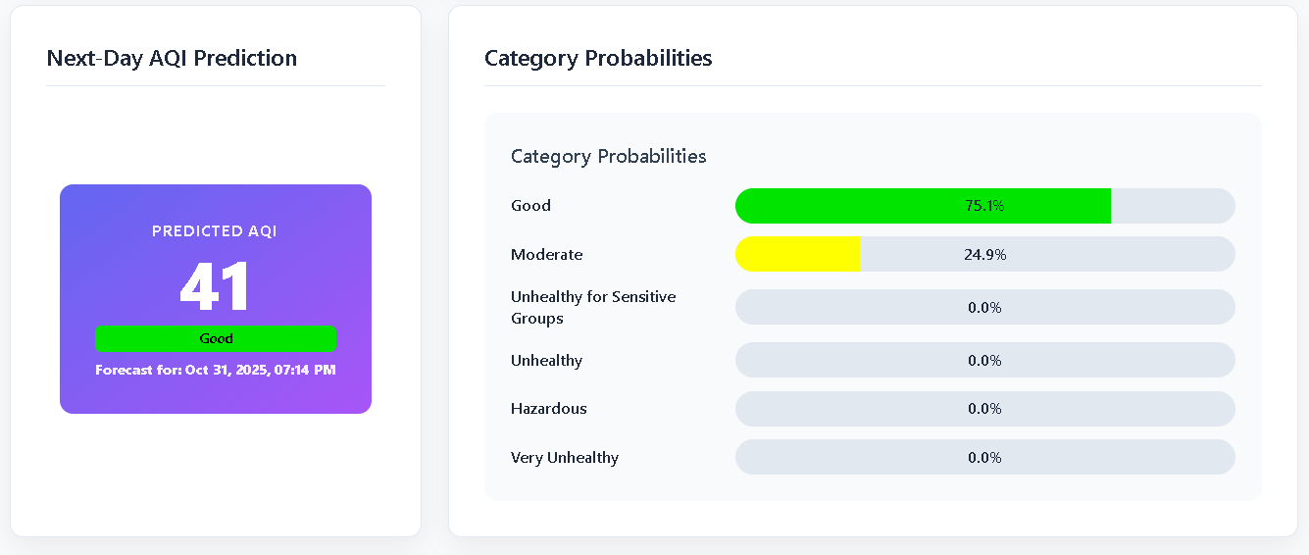
Figure 5.2 – Prediction & Category Probability Panel Examples

- Historical Trend Panel: The historical trend panel contextualizes the forecast by displaying recent AQI trends. It provides insight into historical AQI fluctuations that impact current model predictions.
  - Responsibilities:
    - Present a time-series visualization of at least the most recent 30 days of AQI data for the selected county.
    - Enable visual comparison between historical patterns and forecasted values.
    - Use accessible chart colors and labeling aligned with WCAG 2.1 AA guidelines.

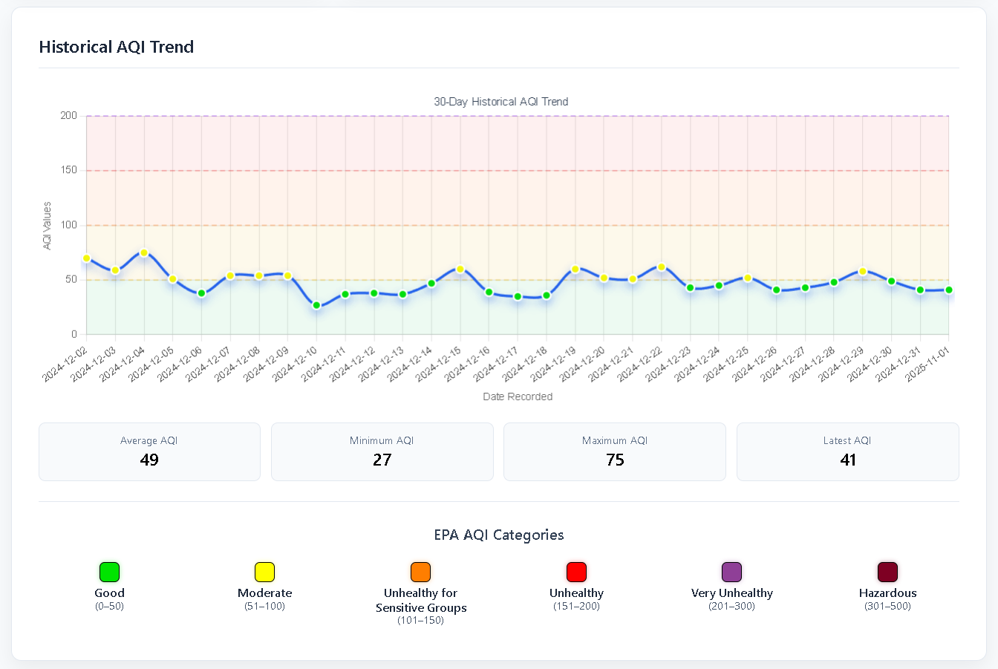
Figure 5.3 – Historical Trend Panel Example
- Model Information Panel: The model information panel summarizes metadata about the predictive model currently in use. It supports user understanding of system performance and model validity.
  - Responsibilities:
    - Display key performance metrics such as mean squared error (MSE), root mean squared error (RMSE), and R² values.
    - Serve as informational reference for evaluating forecast reliably.
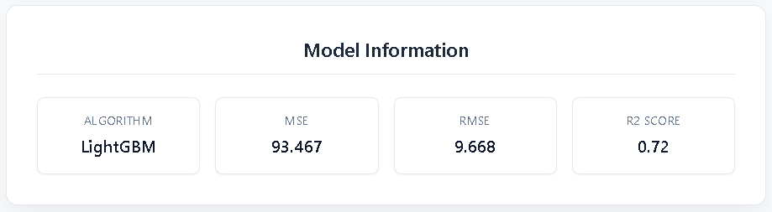
Figure 5.4 – Model Information Panel Example

STATIC MODEL (CLASS DIAGRAMS)
The CLAP system’s backend services are structured as modular route subsystems that collectively manage data ingestion, forecasting, and system monitoring. Each subsystem defines a clear responsibility boundary and interacts with the Domain / Data Transfer Object (DTO) layer to maintain consistency between application logic and API responses that convey next-day AQI values. This design promotes modularity, reuse, and traceability across backend components.
Static Model Design Intent:
The static model defines the internal organization of backend services at the design level, emphasizing interface behavior and subsystem collaboration. The encapsulation of route handlers within the backend enables a clean separation of concerns:
- Routes manage request handling, validation, and response orchestration.
- DTOs define standardized response schemas exchanged between the backend and frontend.
- Shared services (e.g. data access, logging, and model management) provide reusable capabilities without coupling to specific endpoints.
Table 5.1 – Backend Route Subsystems and Responsibilities
Subsystem: | Endpoint(s): | Main Responsibility:
Health Monitoring Service | GET /health | Reports API availability and model readiness status.
Data Refresh Service | POST /aqi/refresh | Regenerates stored datasets and updates forecasts in a single workflow.
County Registry Service | GET /counties | Returns the list of supported counties and associated metadata.
Prediction Service | GET /aqi/predict | Handles forecast requests by performing model inference and returning next-day AQI predictions.
Category Registration Service | GET /categories | Serves AQI category definitions consistent with EPA standards.
Historical Data Service | GET /aqi/historical | Provides recent AQI values for a specified county and state.
Model Metrics Service | GET /model/metrics | Returns model performance indicators (e.g. RMSE, R²).
Class Diagrams:
Figure 5.5 illustrates the logical relationships among backend route subsystems. Each subsystem acts as a service endpoint responsible for receiving client requests, invoking the appropriate processing logic and returning structured JSON responses.
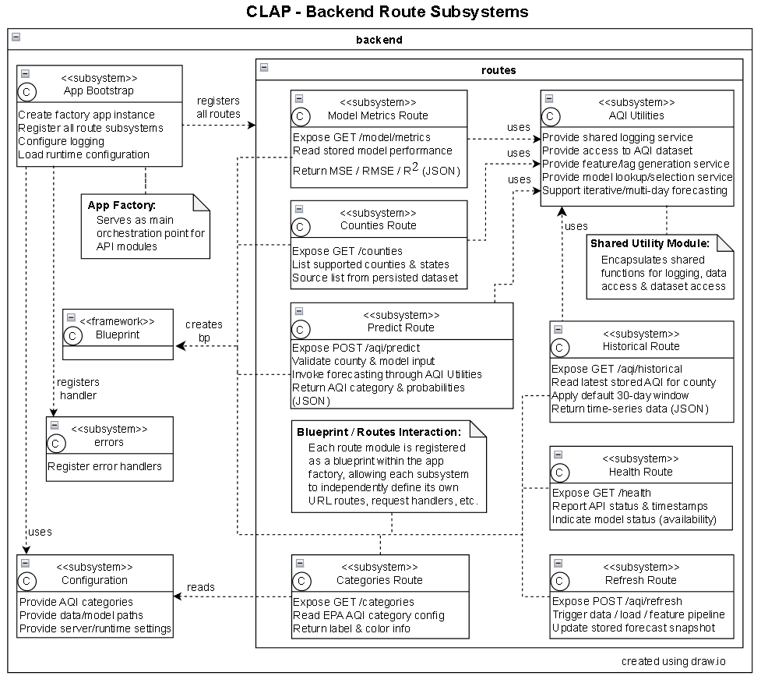
Figure 5.5 – Backend Route Subsystems Class Diagram

Figure 5.5 depicts the DTO layer, which defines the data schemas exchanged between backend services and the frontend dashboard. DTOs enforce uniform response formats, encapsulate key attributes (e.g. AQI category, probability scores, timestamps, etc.), and ensure traceability between server outputs and client visualizations.
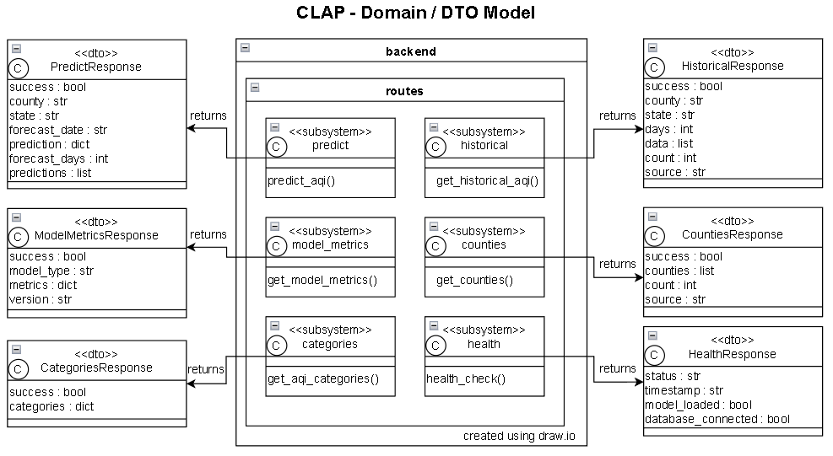
Figure 5.6 – Domain / DTO Model Class Diagram

DYNAMIC MODEL (SEQUENCE DIAGRAMS)
The dynamic model describes how the CLAP system behaves at runtime when a user requests an initial or updated forecast. It shows the order of messages exchanged among the browser UI, backend, route subsystem, shared utilities layer, and the persisted dataset / ML model artifacts.
Figure 5.7 illustrates the runtime interaction for UC2 – Provide County-Level Forecast:
- The sequence begins when the User requests a forecast prediction from the browser dashboard.
- The Browser / UI then issues an HTTP call to the application, which dispatches that request to the Prediction Route Subsystem.
- The Predict Route delegates feature construction and data access the AQI Utility / Data Service layer, which retrieves the most recent county-level AQI records, generated lag features, and the ML artifact to obtain the predicted numeric average AQI for the next day.
- The route then converts this numeric output into a JSON DTO containing the predicted value, timestamp, and corresponding EPA category label.
- The browser then updates the dashboard panels without a full page reload, ensuring responsive visualization.
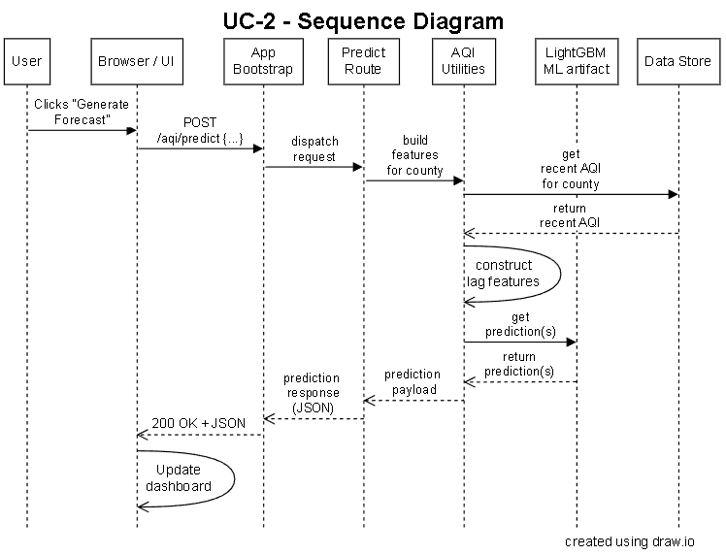
Figure 5.7 – Forecast Generation Sequence Diagram

RATIONALE FOR YOUR DETAILED DESIGN MODEL
The Detailed Design Model refines the architectural description into a precise technical specification that guides implementation and testing. It defines the internal structure, interfaces, and interactions of all major subsystems while maintaining full alignment with the project’s requirements and architectural objectives. This level of design ensures that every software component contributes directly to satisfying the defined functional and non-functional requirements.
- Architectural Refinement: Expands the system architecture (e.g. Client-Server, Layered) into concrete modules and subsystem interfaces that can be implemented.
- Interface Definition: Defines backend route and shared utility modules to ensure predictable integration behavior and consistent data exchange across layers.
- Structural & Behavioral Specification: Represents static structural relationships within the backend and domain models using class diagrams. dynamic runtime behavior using a sequence diagram to illustrate message flow between components.
- Traceability & Verification: Maintains a verifiable link between design elements and the originating system requirements. Each route, data object, and process align with its corresponding FR/NFR identifier to ensure completeness.
- Maintainability & Flexibility: The model abstracts away low-level implementation syntax while emphasizing subsystem responsibilities and interactions, enabling the design to evolve without invalidating the implementation.

TRACEABILITY FROM REQUIREMENTS TO DETAILED DESIGN MODEL
Traceability in the detailed design connects each requirement to specific design elements, enabling systematic verification that the design supports all intended behaviors and quality attributes.
Table 5.2 – FR-to-Design Traceability Matrix
FR ID: | FR Description: | Design Element(s): | API Endpoint(s): | How the FR is captured:
FR-1.1 | Utilize daily EPA AQI data, ingested manually. | Refresh Service  (Data Ingestion Subsystem) | POST /aqi/refresh | The Refresh Service initiates manual ingestion of EPA data.
FR-2.1 | Store historical AQI data in CSV. | Data Persistence Layer  (Historical Subsystem) | (internal); surfaced via GET /aqi/historical | Historical data persisted locally and retrieved through the Historical Data Service for visualization.
FR-2.2 | Generate lag features for prediction. | Feature Engineering Component within Data Processing System | POST /aqi/predict (indirect) | Feature generation occurs as part of the prediction pipeline to enhance model input accuracy.
FR-3.1 | Train and run a predictive model using historical AQI + county location. | Model Management System | POST /aqi/predict, GET /model/metrics | Model is loaded and executed by the backend prediction service, providing inference and evaluation metrics.
FR-3.2 | Output next-day AQI category for selected county. | Prediction Service  (Backend Forecast Subsystem) | POST /aqi/predict | Forecast requests return the predicted AQI category for the next day based on latest inputs.
FR-3.3 | Provide probability score for each category. | Prediction Service w/ Model Probability Interface | POST /aqi/predict | Response payload includes per-category probabilities derived from the model’s classification output.
FR-4.1 | Provide a GUI for visualizing AQI data & predictions. | Web Dashboard  (Frontend Presentation Subsystem) | GET / | Browser dashboard renders forecast cards and charts using data returned by the API.
FR-4.2 | Display chart of last 30 days + next-day category with probabilities. | AQI Trend View  (Dashboard Visualization Panel) | GET /aqi/historical; POST /aqi/predict | Dashboard aggregates historical data & forecast results into a single 30-day visual trend.
FR-4.3 | Provide Refresh control buttons to update from local dataset and regenerates forecast. | Frontend Action Handler  (User Interaction Controller) | POST /aqi/refresh; GET /aqi/historical; POST /aqi/predict | Refresh action initiates a data refresh & subsequent re-render of updated forecasts.

Table 5.3 – NFR-to-Design Traceability Matrix
NFR ID: | NFR Description: | Design Element(s): | API Endpoint(s): | How the NFR is captured:
NFR-1.1 | Ingestion + validation + features ≤ 60 s for one county. | Refresh Service  (Data Ingestion Subsystem) | POST /aqi/refresh | Optimized data I/O and feature routines minimize execution time within performance thresholds.
NFR-1.2 | Dashboard renders ≤ 5s after Refresh. | Built assets  (Frontend Presentation Subsystem) | GET / | Optimized building and lightweight JSON reduce load time & improve perceived responsiveness.
NFR-2.1 | Use EPA category labels (e.g. Good…Hazardous). | Backend  (AQI Category Service) | GET /categories | Backend serves canonical EPA labels consumed by UI elements.
NFR-2.2 | Use distinct EPA/AirNow colors per category. | Color Mapping  (Frontend Visualization Layer) | GET /categories | Frontend applies consistent color codes aligned with EPA visual standards.
NFR-3.1 | Conform to WCAG 2.1 AA (SC 1.4.1, 1.4.3, 1.4.11). | Frontend  (UI Accessibility Layer) | N/A (UI) | Interface design ensures color contrast, focus order, and keyboard navigation compliance.
NFR-4.1 | Daily ingest succeeds on ≥ 90% of runs. | Ingestion Subsystem w/ Error Recovery & Logging | POST /aqi/refresh | Error messages and structured logging support ingest success tracking.
NFR-5.1 | Dashboard availability ≥ 99% over any 30-day period. | Health Check & Uptime  (System Monitoring Service) | GET /health | Health endpoint enables availability tracking and alerts for service interruptions.
NFR-6.1 | Implement structured logging for key operations. | Backend Utility Layer  (Shared Logging Service) | All API Routes | Structured logging captures timestamps, event types, and status for core operations.
NFR-6.2 | Logs include timestamps and error details. | Shared Logger & Formatter Configuration | All API Routes | Logging formatter adds timestamp & details for diagnostic clarity.

EVIDENCE OF CONFIGURATION MANAGEMENT
GitHub serves as the configuration management platform for the design document. Evidence of configuration tracking is provided through version history tables listing commit hashes, dates, and comparison links showing difference across revisions:
Table 5.4 – Configuration Management – Design
ID: | Date of Change: | Version Before: | Version After: | Author: | Review -Change Summary: | Reviewers:
1 | 10/29/25 | v0.1 (3f3068a) | v0.2 (8ea3327) | Jay Chung (cwc130330) | Interim draft edit | All Team Members
2 | 10/31/25 | v0.2 (8ea3327) | v0.3 (5077f05) | Jay Chung (cwc130330) | Revision Edit – All sections | All Team Members
3 | 11/01/25 | v0.3 (5077f05) | v0.4  (973a557) | Jay Chung (cwc130330) | Consistency Pass & Revision of graphs | All Team Members

Table 5.5 – Difference Link – Architecture
ID: | Difference Link:
1 | https://github.com/cchung7/rtx_team1/compare/3f3068a..8ea3327
2 | https://github.com/cchung7/rtx_team1/compare/8ea3327..5077f05
3 | https://github.com/cchung7/rtx_team1/compare/5077f05..973a557
4 | https://github.com/cchung7/rtx_team1/compare/973a557..663b863

TEST PLAN
REQUIREMENTS/SPECIFICATIONS-BASED SYSTEM LEVEL TEST CASES
System-level test cases are defined from functional and non-functional requirements, ensuring that externally observable behaviors are validated according to ISO/IEC/IEEE 29119 (1-4) principles.
The test suite includes five black-box tests that verify ingestion, dashboard workflows, failure handling, reliability, and multi-county prediction behavior.
Table 6.1 – Test Case #1
Test Case Identifier: | TC-01 | Test-level: | System Level, Black-Box
Test Case Description: | Daily Ingest & Feature Engineering Pipeline (End-to-End). | Priority: | High
Objective: | Verify end-to-end data ingestion & feature engineering with both valid & invalid EPA datasets.
Traceability: | UC-1, FR-1.1, FR-2.*, NFR-1.1, NFR-4.1, NFR-6.*
ISO-25010: | - Functional Suitability:  - Functional Completeness: Covers ingestion & feature-engineering workflow.  - Functional Correctness: Ensures only valid rows are retained.  - Functional Appropriateness: Produces ML-ready data.  - Performance Efficiency:  - Time Behavior: Ingest completes ≤ 60s.  - Resource Utilization: Does not consume excessive CPU & memory.  - Capacity: System scales appropriately as more EPA data is added.  - Reliability:  - Fault tolerance: Handles corrupted or malformed datasets gracefully.  - Recoverability: Structured logging diagnoses ingestion failures.  - Availability: Ingestion can be run manually on demand.  - Maintainability:  - Analyzability: Logs are structured for debugging & analysis.  - Testability: Output artifacts are externally observable.
Test Techniques Used: | - Equivalence Partitioning: Partition datasets into behaviorally distinct classes:  - Valid dataset  - Invalid / corrupted datasets (e.g. missing columns, invalid values, malformed rows)  - Requirements-Based Testing: Confirms direct mapping to FR/NFRs.  - Cause-Effect Graphing: Model dataset validation rules and verify that each defect leads to the correct outcome:  - Missing columns are filtered / skipped during ingestion & logged.  - Non-numeric AQI values are filtered during ingestion & logged.  - Empty file results in error, failure is logged.
Pre-conditions: | - CLAP environment installed & configured.  - Valid EPA dataset prepared and available.  - Corrupt EPA dataset prepared and available.
Post-Conditions: | - On successful ingestion, a new cleaned feature-engineered CSV exists.  - Logs contain a complete record of the ingestion run.
Inputs/Triggers: | Tester runs ingestion manually using:  - Valid EPA dataset  - Invalid / Corrupted EPA dataset
Expected Results: | For Valid Dataset:  - Dataset structure is validated successfully.  - A new cleaned historical AQI CSV is generated.  - Lag / feature columns generated accurately.  - Logs include:  - Validation success  - Ingestion start / end  - Number of rows processed  - Feature-engineering output  - Ingestion completes in ≤ 60s.  For Invalid / Corrupted Dataset:  - Validation detects structural or value errors.  - Only valid rows are processed; invalid rows are skipped.  - Structured logs capture:  - Error type  - Cause details  - Outcome  - Ingestion completes in ≤ 60s.

Table 6.2 – Test Case #2
Test Case Identifier: | TC-02 | Test-level: | System Level, Black-Box
Test Case Description: | Dashboard Refresh | Priority: | High
Objective: | Verify normal dashboard behavior under nominal data conditions; dashboard meets performance limits, EPA-category correctness, and required usability / accessibility behavior (WCAG 2.1 AA).
Traceability: | UC-2, FR-3.*, FR-4.*, NFR-1.1, NFR-2.1, NFR-2.2, NFR-3.1, NFR-6.*
ISO-25010: | - Functional Suitability:  - Functional Completeness: All required UI elements, charts, forecast outputs are displayed.  - Functional Correctness: Model outputs and probabilities are displayed accurately for the selected state / county.  - Functional Appropriateness: The user achieves the forecasting goal with minimal steps.  - Performance Efficiency:  - Time Behavior: Dashboard refresh completes ≤ 5s.  - Resource Utilization: API and model calls execute efficiently from the user’s perspective.  - Capacity: System supports refreshing for multiple counties without visible degradation.  - Interaction Capability:  - Appropriateness Recognizability: Controls, labels, and legends clearly indicate their purpose.  - Operability: Controls (e.g. Select, refresh) are intuitive and easy to use.  - User Error Protection: UI prevents or limits invalid selections where applicable.  - Self-Descriptiveness: Chart legends, labels, and textual instructions / tooltips are understandable.  - Reliability:  - Fault tolerance: Minor data unavailability is handled gracefully at the UI level (e.g. clear messaging).  - Availability: Dashboard responds consistently when the user interacts with it under normal conditions.  - Maintainability:  - Analyzability: Logs capture user actions & system responses for diagnostics.  - Testability: Dashboard and logs make behavior observable and verifiable.
Test Techniques Used: | - Classification Tree Method: Partition combinations (e.g. County x Browser x Dashboard State) to ensure rendering is stable across basic environmental differences.  - Requirements-Based Testing: Verifies WCAG, EPA color rules and prediction correctness.  - Scenario-based Testing: Tests the normal user path (e.g. dashboard refresh view results).  - Decision Table Testing: Tests county conditions affecting prediction display readiness.
Pre-conditions: | - Backend and frontend servers running.  - Dashboard deployed and reachable.  - ML model artifact loaded.  - Network connection stable.  - Browser with accessibility support installed.
Post-Conditions: | - Dashboard remains fully usable and interactive.
Inputs/Triggers: | - Initial Load (empty dashboard) Steps:  - Open dashboard in browser.  - Navigate via keyboard & screen reader.  - Evaluate labels, contrasts, and headings.  - Refresh Workflow Steps:  - Select county / state.  - Click Refresh Forecast.  - Observe chart, prediction, and probabilities.  - Re-check accessibility.
Expected Results: | - Correct prediction & probability distribution (sum = 1.0).  - Correct 30-day AQI chart, EPA colors, and category labels.  - Dashboard refresh ≤5 s.  - Keyboard navigation works.  - Screen reader correctly identifies controls and outputs.  - WCAG 2.1 AA color contrast holds.  - Logs record data fetch & prediction events.

Table 6.3 – Test Case #3
Test Case Identifier: | TC-03 | Test-level: | System Level
Test Case Description: | Error Handling & Degraded Mode Behavior | Priority: | High
Objective: | Verify correct handling of error conditions encountered during the Refresh Forecast workflow; ensure that missing / incomplete historical data, a corrupted model file, or invalid feature columns result in correct degraded behavior.
Traceability: | UC-2, FR-3.1, FR-4.*, NFR-2.2, NFR-6.*
ISO-25010: | - Functional Suitability:  - Functional Correctness: System reacts correctly to invalid states.  - Functional Appropriateness: Provides warnings instead of crashing or failing silently.  - Interaction Capability:  - User Error Protection: Clear feedback to signify error occurrence.  - Self-Descriptiveness: Error message describes the problem.  - Operability: UI remains accessible after error.  - Reliability:  - Fault tolerance: System handles missing or corrupt resources without crashing.  - Recoverability: System avoids fatal failure.  - Availability: Dashboard remains accessible after errors occur.  - Maintainability  - Analyzability: Structured logs capture errors for diagnosis.
Test Techniques Used: | - Cause-Effect Graphing: Map each error condition to expected UI and logging outcomes.  - Decision Table Testing: Exercise combinations of error states; ensure correct warnings & log entries are produced for every combination.  - Requirement-Based Testing: Verifies error responses.
Pre-conditions: | - Backend and frontend servers up and running.  - Dashboard reachable.  - Tester allowed to manipulate / remove the ML model artifact or ML-ready CSV.
Post-Conditions: | - Dashboard remains fully usable and navigable.  - Logs provide sufficient detail for error diagnosis.
Inputs/Triggers: | - Introduce each error individually while performing Refresh:  - Missing or incomplete CSV file.  - Corrupted ML Model artifact.  - Missing or invalid feature columns.
Expected Results: | - Clear user-visible warning.  - Dashboard does not freeze or crash after error.  - Last-known-good prediction shown (if applicable).  - Structured error logs recorded.

Table 6.4 – Test Case #4
Test Case Identifier: | TC-04 | Test-level: | System Level
Test Case Description: | Reliability & Availability Monitoring | Priority: | Medium
Objective: | Verify long-term operational behavior over a defined observation window; check that the system meets reliability & availability thresholds; generate sufficient logs for error diagnosis.
Traceability: | UC-1, UC-2, NFR-4.1, NFR-5.1, NFR-6.*
ISO-25010: | - Reliability:  - Faultlessness: Ingestion & dashboard operations experience relatively few failures.  - Availability: Dashboard remains available for at least 99% of the observation period.  - Fault tolerance: System withstands transient faults without long-term downtime.  - Recoverability: System recovers from transient issues without manual adjustment.  - Performance Efficiency:  - Capacity: System maintains stable behavior under expected workload across the observation window.  - Resource Utilization: Resource usage remains within acceptable bounds during extended operation.  - Maintainability:  - Analyzability: Logs are sufficient to compute reliability & availability statistics.  - Testability: Monitoring outputs provides evidence for NFR compliance.
Test Techniques Used: | - Scenario Testing: Repeated multi-day scenario.  - Requirement-Based Testing: Verifies direct mapping to reliability & availability NFRs.  - Random Testing: Introduces randomized access times for dashboard requests during the observation window.
Pre-conditions: | - CLAP system deployed in stable environment.  - Monitoring tool or script configured & running.  - Observation window & acceptance thresholds are defined .
Post-Conditions: | - A reliability & availability report can be generated using captured logs and monitoring data.  - Able to verify NFR-4.1 & NFR 5.1.
Inputs/Triggers: | - Periodically send synthetic requests to the dashboard to check availability and responsiveness.
Expected Results: | - At least 90% of ingestion runs complete successfully during the observation period.  - Dashboard availability is at least 99% over the same period.  - Logs and monitoring data provide enough information to compute reliable metrics and identify major outages.

Table 6.5 – Test Case #5
Test Case Identifier: | TC-05 | Test-level: | System Level
Test Case Description: | Reliability & Availability Monitoring | Priority: | Medium
Objective: | Verify that prediction behavior remains correct, stable, and usable across multiple counties with different historical-data characteristics; check for consistent labels, categories, and structured logs.
Traceability: | UC-2, FR-3.*, FR-4.*, NFR-1.2, NFR-2.1, NFR-2.2, NFR-6.*
ISO-25010: | - Functional Suitability:  - Functional Completeness: Prediction & visualization executes correctly for all tested county inputs.  - Functional Correctness: Each selected county yields a valid next-day category and probability distribution.  - Functional Appropriateness: System handles diverse county data characteristics without manual adjustment.  - Performance Efficiency:  - Time Behavior: Dashboard refresh completes ≤ 5s for each representative county.  - Capacity: System supports many different counties and data distributions without degradation in responsiveness.  - Interaction Capability:  - Appropriateness Recognizability: All labels and legends remain correct.  - Operability: User interaction remains consistent and intuitive.  - Self-Descriptiveness: Chart legends and prediction summaries remain clear & understandable.  - Reliability:  - Fault tolerance: System handles sparse or volatile datasets without crashes or inconsistent UI states.  - Availability: Dashboard remains responsive across repeated refreshes for many counties.  - Maintainability:  - Analyzability: Structured logs reflect successful & anomalous operations per county.
Test Techniques Used: | - Equivalence Partitioning: Define county “test classes” based on data characteristics (e.g. testing partitions):  - Dense-data counties (e.g. Complete 30-day history)  - Sparse-data counties (e.g. Missing or limited days in history)  - Stable-pattern counties (e.g. Minimal AQI variation)  - High-variability counties (e.g. Frequent AQI fluctuations)  - Classification Tree Method: Combine dimensions to ensure coverage across representative combinations.  - Scenario-based Testing: Tests normal path for several counties.  - Requirement-Based Testing: Tests prediction correctness, chart correctness, and refresh time.
Pre-conditions: | - Backend and frontend servers operational.  - Historical ingestion completed for the selected representative counties.
Post-Conditions: | - Dashboard remains functional after testing multiple counties.  - Tester can re-run Refresh Forecast or select additional counties without restarting the system.
Inputs/Triggers: | - For each county/class:  - Open dashboard  - Select representative county / state  - Click Refresh Forecast.  - Observe prediction, probabilities, and chart rendering.
Expected Results: | - A prediction is returned for each county.  - EPA category colors and labels remain consistent.  - 30-day AQI chart renders correctly using available historical data.  - Dashboard refresh completes within ≤ 5s regardless of county class.  - No county-triggers application errors.  - Logs reflect successful historical data fetch & model execution.

TECHNIQUES USED FOR TEST GENERATION
The test suite uses a structured, black-box design approach grounded in ISO/IEC/IEEE 29119-4. Each technique contributes uniquely to use case & requirements coverage, and behavioral completeness.
Test Generation Techniques:
- Equivalence Partitioning (EP): This technique groups inputs into behaviorally similar partitions, allowing representative values to stand in for the whole class. It’s used when requirements define clear categories of input behavior.
- Rationale: EP reduces redundant testing while ensuring representative coverage of distinct input conditions.
- Applied in: TC-01, TC-05.
- Classification Tree Method (CTM): This technique organizes independent input dimensions into structured combinations.
- Rationale: CTM ensures systematic, meaningful coverage of important multi-dimensional input combinations without requiring exhaustive testing.
- Applied in: TC-02, TC-05.
- Decision Table Testing: This technique enumerates combinations of conditions and their required outputs.
- Rationale: Decision tables cover each meaningful combinations of multiple error causes that generate distinct behaviors.
- Applied in: TC-03
- Cause-Effect Graphing: Used to represent.
- Rationale: This technique ensures that all rule-based behaviors are systematically exercised.
- Applied in: TC-01, TC-03.
- Scenario-Based Testing: This technique derives tests from real user workflows (e.g. use-case models).
- Rationale: This technique is used to predict and visualize CLAP’s user interactions & functional behaviors organized around use cases.
- Applied in: TC-02, TC-04, TC-05.

- Random Testing: Random testing selects input or event timing unpredictably within defined operational constraints.
- Rationale: Random event timing ensures that reliability is not tied to one fixed execution pattern, while defining availability expectations.
- Applied in: TC-04.
- Requirement-Based Testing: This technique forms tests directly from the wording, constraints, and semantics of the FRs and NFRs.
- Rationale: Appropriate for ensuring 100% requirements coverage.
- Applied in: TC-01, TC-02, TC-03, TC-04, TC-05.

Black-box vs. White-box Testing:
- Black-Box Testing:
- All system-level tests in this plan use black-box techniques focusing on:
  - Inputs (e.g. EPA datasets, dashboard interactions).
  - Observable outputs (e.g. Charts, predictions, and warnings).
  - Timing behavior (e.g. Ingest time, dashboard refresh time).
  - External artifacts (e.g. Logs, CSV files, ML model artifacts).
- This approach supports:
  - Requirements-based testing
  - Scenario-based testing (e.g. Use-case validation)
- White-Box Testing (Out of Scope):
- White-box techniques (e.g. Branch, statement, or path coverage) are performed at the development / unit-testing level and are not relevant to system-level verification activities.

Criteria for Measuring Test Quality:
Test adequacy is measured using industry-standard metrics that evaluate completeness, performance conformance, reliability, usability, accessibility, and error coverage:
- Requirements Coverage:
- Every FR and NFR is mapped to at least one system-level test case, ensuring 100% requirements coverage at the system level.
- Performance Compliance:
- Performance-related NFRs are verified through observable timing measurements (e.g. TC-01, TC-02, TC-05).
- Reliability & Availability Metrics:
- Evaluated over a defined observation window (e.g. TC-04), demonstrating long-term system robustness.
- Usability & Accessibility Compliance:
- Verified through WCAG 2.1 AA checklist (e.g. TC-02), including keyboard navigation, ARIA labels, screen-reader compatibility, EPA-compliant color mapping, and contrast ratio verification.
- Error-Handling Completeness:
- Cause-effect graphing and decision tables ensure that error conditions & combinations are covered (e.g. TC-03), ensuring robust error behavior.
  - NOTE: Error classification results in correct user-visible warnings, fallback behavior, and structured logging.

TRACEABILITY OF TEST CASES TO USE CASES:
Traceability ensures that every requirement and use case receives direct test coverage according to ISO/IEC/IEEE 29119 standards, ensuring that:
- Every system-level test case covers at least one use case.
- Every use case is validated by one or more test cases.
- Functional and non-functional requirements are tied to explicit verification steps.

Table 6.6 provides a direct mapping between each system-level test case and the use case(s) it validates. This matrix ensures that all functional behaviors described in UC-1 & UC-2 receive explicit testing coverage. By establishing this linkage, stakeholders can clearly see how the test suite supports end-user goals and operational behaviors captured in the requirements, in alignment with ISO/IEC/IEEE 29119 principles for complete lifecycle traceability.

Table 6.6 – TC-to-UC Traceability Matrix
Test Case: | Use Case Covered: | Mapping Notes:
TC-01 | UC-1 | TC-01 tests the ingestion, validation, feature generation, CSV regeneration, and logging described in UC1.
TC-02 | UC-2 | TC-02 validates the entire UC-2 dashboard workflow, from prediction to visualization to accessibility.
TC-03 | UC-2 | TC-03 covers error-handling tests only occur during the UC-2 “Refresh Forecast” workflow.
TC-04 | UC-1, UC-2 | TC-04 validates NFRs associated with UC1 and UC2; Reliability applies to UC-1 ingestion and UC-2 dashboard availability. Long-term observation spans both workflows.
TC-05 | UC-2 | TC-05 validates that forecast & visualization operates correctly for multiple representative counties.

Table 6.7 ensures that every functional requirement is testable and explicitly verified.
Table 6.7 – FR-to-TC Traceability Matrix
FR ID: | FR Description: | Covered by: | How the FR is captured:
FR-1.1 | Ingest daily EPA AQI dataset | TC-01 | TC-01 captures ingestion pipeline behaviors, performance, and logging.
FR-2.1 | Store historical AQI data (e.g. CSV generation) | TC-01 | TC-01 ensures that a new CSV is generated / updated per successful ingestion run.
FR-2.2 | Generate lag / feature columns | TC-01 | TC-01 validates existence & correctness of the feature engineering output.
FR-3.1 | Run predictive model | TC-02, TC-03, TC-05 | TC-02 captures model execution, TC-03 tests failure cases, and TC-05 captures multi-county behavior.
FR-3.2 | Output next-day AQI category | TC-02, TC-05 | TC-02 verifies this during refresh per single county, and TC-05 verifies this during long-term multi-county testing.
FR-3.3 | Output probability distribution | TC-02, TC-05 | TC-02 ensures that the sum = 1.0, TC-05 validates correctness.
FR-4.1 | Provide GUI dashboard | TC-02, TC-03, TC-05 | TC-02 & TC-05 capture visualization, accessibility & interaction under normal conditions, while TC-03 captures these behaviors during degraded conditions.
FR-4.2 | Display 30-day AQI chart & next-day prediction | TC-02, TC-05 | TC-02 verifies that charts populate correctly per single county, while TC-05 does the same for long-term multi-county testing.
FR-4.3 | Refresh Forecast invokes complete update | TC-02, TC-03 | TC-02 verifies this feature under normal conditions, while TC-03 verifies this feature under degraded conditions.

Table 6.8 ensures that quality attributes are verified across the test suite.
Table 6.8 – NFR-to-TC Traceability Matrix
NFR ID: | NFR Description: | Covered by: | How the NFR is captured:
NFR-1.1 | Ingestion ≤ 60s | TC-01 | TC-01 requires time-behavior measurement.
NFR-1.2 | Dashboard render ≤ 5s | TC-02, TC-05 | TC-02, TC-05 require NFR verification..
NFR-2.1 | EPA category consistency | TC-02, TC-05 | TC-02, TC-05 require category-color correctness.
NFR-2.2 | Visual usability | TC-02, TC-03, TC-05 | TC-02, TC-03, TC-05 require layout clarity, interactivity & visual cues.
NFR-3.1 | Accessibility (WCAG 2.1 AA) | TC-02 | TC-02 requires keyboard navigation, ARIA & contrast.
NFR-4.1 | Reliability ≥ 90% | TC-01, TC-04 | TC-01 & TC-04 require successful ingestion rates.
NFR-5.1 | Availability ≥ 99% | TC-04 | TC-04 requires dashboard uptime monitoring.
NFR-6.1 | Structured logging | TC-01, TC-02, TC-03, TC-04, TC-05 | Most test cases test maintainability features like logging (cross cutting).
NFR-6.2 | Log entries with timestamp and error details | TC-01, TC-02, TC-03, TC-04, TC-05 | Most test cases logging features (e.g. timestamp & error details).

Table 6.9 ensures that each test case is tied to at least one FR or NFR, and that critical workflows are verified. By establishing this linkage, stakeholders can clearly see how the test suite fully supports verification of both user-facing behaviors and quality attributes, in alignment with ISO/IEC/IEEE 29119 principles for complete lifecycle traceability.
Table 6.9 –TC-to-UC / FR / NFR Traceability Matrix
TC ID: | Requirement(s) Covered: | TC Description:
TC-01 | FR-1.1, FR-2.*, NFR-1.1,  NFR-4.1, NFR-6.* | TC-01 validates requirements associated with ingestion pipeline behaviors, performance, and logging.
TC-02 | FR-3.*, FR-4.*, NFR-1.2,  NFR-2.*, NFR-3.1, NFR-6.* | TC-02 validates the dashboard workflow, including prediction, visualization, and accessibility requirements.
TC-03 | FR-3.1, FR-4.1, FR-4.3,  NFR-2.2, NFR-6.* | TC-03 covers error-handling tests for the “Refresh Forecast” workflow.
TC-04 | NFR-4.1, NFR-5.1, NFR-6.* | TC-04 covers reliability, ingestion, and dashboard availability. Long-term observation spans both workflows.
TC-05 | FR-3.*, FR-4.1, FR-4.2,  NFR-1.2, NFR-2.*, NFR-6.* | TC-05 validates the dashboard workflow, including prediction, visualization, and accessibility requirements for multiple representative counties.

EVIDENCE OF CONFIGURATION MANAGEMENT
GitHub serves as the configuration management platform for the test plan document. Evidence of configuration tracking is provided through version history tables listing commit hashes, dates, and comparison links showing difference across revisions:
Table 6.10 – Configuration Management – Test Plan
ID: | Date of Change: | Version Before: | Version After: | Author: | Review -Change Summary: | Reviewers:
1 | 11/10/25 | v0.1 (7411f5e) | v0.2 (9766a9e) | Jay Chung (cwc130330) | Interim draft edit | All Team Members
2 | 11/16/25 | v0.2 (9766a9e) | v0.3 (e3a63cd) | Jay Chung (cwc130330) | Consistency Pass | All Team Members
3 | 11/21/25 | v0.3 (e3a63cd) | v0.4 () | Jay Chung (cwc130330) | Consistency Pass | All Team Members

Table 6.11 – Difference Link – Test Plan
ID: | Difference Link:
1 | https://github.com/cchung7/rtx_team1/compare/7411f5e..9766a9e
2 | https://github.com/cchung7/rtx_team1/compare/9766a9e..e3a63cd
3 | https://github.com/cchung7/rtx_team1/compare/e3a63cd..

EVIDENCE OF CONFIGURATION MANAGEMENT (FINAL PROJECT REPORT)
GitHub serves as the configuration management platform for the final project report document. Evidence of configuration tracking is provided through version history tables listing commit hashes, dates, and comparison links showing difference across revisions:
Table 7.1 - Single file revision
ID: | Date of Change: | Version Before: | Version After: | Author: | Review -Change Summary: | Reviewers:
1 | 12/04/25 | v0.1 (f8b6f9e) | v0.2 () | Jay Chung (cwc130330) | Interim draft edit | All Team Members
2
3
4

Table 7.2 - Difference link
ID: | Difference Link:
1 | https://github.com/cchung7/rtx_team1/compare/f8b6f9e..
2
3
4

ENGINEERING STANDARDS AND MULTIPLE CONSTRAINTS
Engineering Standards:
- IEEE Std 1058-1998: Software Project Management Plans [pdf]
- PMBOK® Guide: Project Management Body of Knowledge [pdf]
- IEEE Std 12207: Software Life Cycle Processes [pdf]
- IEEE Std 15939: Measurement Process [pdf]
- ISO/IEC/IEEE Std 29148-2018: Systems and Software Engineering
§ Life Cycle Processes
§ Requirements Engineering [pdf]

- IEEE Std 1058-1998: Software Project Management Plans [pdf]
- PMBOK® Guide: Project Management Body of Knowledge [pdf]
- IEEE Std 12207: Software Life Cycle Processes [pdf]
- IEEE Std 15939: Measurement Process [pdf]
- ISO/IEC/IEEE Std 29148-2018: Systems and Software Engineering
§ Life Cycle Processes
§ Requirements Engineering [pdf]
- IEEE Std 1471-2000: Software Architecture [pdf]
- ISO/IEC/IEEE Std 42030:2019: Software, Systems and Enterprise Architecture Evaluation Framework [pdf]
- IEEE Std 1016-1998-(Revision-2009): Software Design [pdf]
- IEEE Std 829-1983: Software Testing [pdf]
- ISO/IEC/IEEE Std 29119-1-(Revision-2022): Part 1 - Software Testing General Concepts [pdf]
- ISO/IEC/IEEE Std 29119-2-(Revision-2021): Part 2 - Test Process [pdf]
- ISO/IEC/IEEE Std 29119-3-(Revision-2021): Part 3 - Test Documentation [pdf]
- ISO/IEC/IEEE Std 29119-4-(Revision-2021): Part 4 - Test Techniques [pdf]

Multiple Constraints:
- Project may utilize one data set so long as multiple fields are used to train the predictive analytics model.
- Frontend must conform to WCAG 2.1 Level AA accessibility requirements for visual content (e.g. SC 1.4.1 “Use of Color”, SC 1.4.3 “Contract (Minimum)”, SC 1.4.11 “Non-text Contrast”).
- Due to dataset limitations, the AQI forecast generated by the ML Learning model reflects the daily average AQI.

ADDITIONAL REFERENCES
- Larson, E. and Gray, C., 2014. Project Management: The Managerial Process. McGraw Hill
- Humphrey, W.S. and Thomas, W.R., 2010. Reflections on Management: How to Manage Your Software Projects, Your Teams, Your Boss, and Yourself. Pearson Education
- Signh, A. (2022). Introduction to Machine Learning Lifecycle. [Figure]. In What is machine learning lifecycle?. NashTech. Retrieved from https://blog.nashtechglobal.com/introduction-to-machine-learning-lifecycle/
- Lamsweerde, A.V., 2009. Requirements Engineering: From System Goals to UML Models to Software Specifications. John Wiley
- A. J. Lattanze, Architecting Software Intensive Systems. CRC Press, 2008.
- L. Bass, P. Clements, and R. Kazman, Software Architecture in Practice, 3rd ed. Upper Saddle River (N.J.): Addison-Wesley, 2013.
- Larman, C., 2012. Applying UML and Patterns: An Introduction to Object Oriented Analysis and Design and Iterative Development. Pearson Education
- Hyman, B., 1998. Fundamentals of Engineering Design. New Jersey: Prentice Hall
- Simon, H.A., 2014. A Student's Introduction to Engineering Design: Pergamon Unified Engineering Series (Vol. 21). Elsevier
- Jorgensen, P.C., 2013. Software Testing: A Craftsman's Approach. Auerbach Publications
- Mathur, A.P., 2013. Foundations of Software Testing, 2/e. Pearson Education

ACKNOWLEDGEMENT

The project team would like to acknowledge the guidance and support provided by Dr. Eric Wong and his staff – Mr. Zizhao Chen and Mr. Chih-Wei Hsu – from the University of Texas at Dallas Software Engineering Department. Their assistance in project accountability and documentation review ensured that our work remained aligned with established software engineering standards.

Next, the project team leader would like to acknowledge David Santos and Amelia Quinn for their outstanding contributions to the development of the CLAP system. David provided significant support in implementing the system’s requirements, while Amelia contributed essential insight to the system’s architectural design and functionality through structured code reviews.

Finally, the team extends sincere appreciation to our Raytheon project sponsors for their guidance, technical insight, and continued support throughout the development of the CLAP system. Their expectations, technical expertise, and feedback played a central role in shaping the project’s requirements, goals, and quality standards.

